NC/NP form removal and new location
The following forms Nonconformance Nonperformance Dept. Addendum.docx and Nonconformance Nonperformance Concurrence.docx have been removed from the region pantry and you will find them at this link https://awpkb.dot.wi.gov/Content/constr/Pantry/StatewideForms.htm in AWPKB under Construction>Pantry>Statewide forms drop down the QMP form templates

155 QMP Template form removal and new location
All qmp templates in the region pantry have been removed.
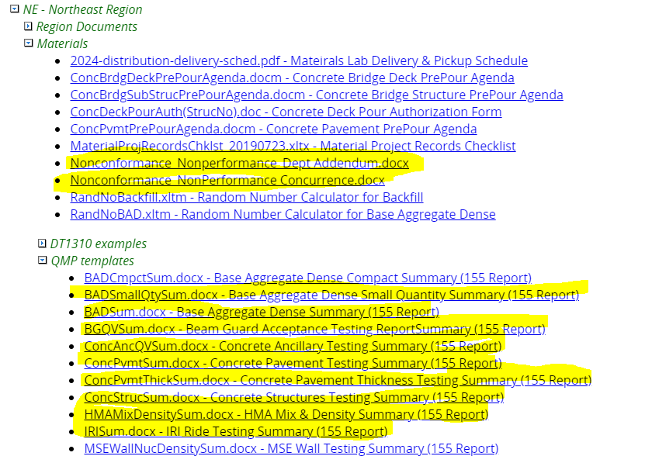
You will find them at this link https://awpkb.dot.wi.gov/Content/constr/Pantry/StatewideForms.htm in AWPKB under Construction>Pantry>Statewide forms drop down the QMP form templates.

Any questions, contact Travis Maatta, 920-366-5790 travis.maatta@dot.wi.gov

